|  |  |  |  |  |  |
| --- | --- | --- | --- | --- | --- |
| Date | 8-Dec-22 | | | Tester Name | Mohammad Yusuf |
| Environment | Penfax - Test | | | Login used |  |
| Operating System | Windows | Version: | Update: | | |
| Software Used | Select Software | Version: | Update: | | |
| Select Software | Version: | Update: | | |
| Release version |  | | | | |
| Title | Tick Leave Repaid Checkbox, and confirm service is added | | | | |
| Test Type | Regression | | | | |
| Test Scenario |  | | | | |
|  |  | | | | |
| Expected Results |  | | | | |
| Pass/Fail | Select | | | JIRA# | N/A |

Describe your steps with screenshots:

Navigate to Employee Profile-> Leaves Section

Add the Leave

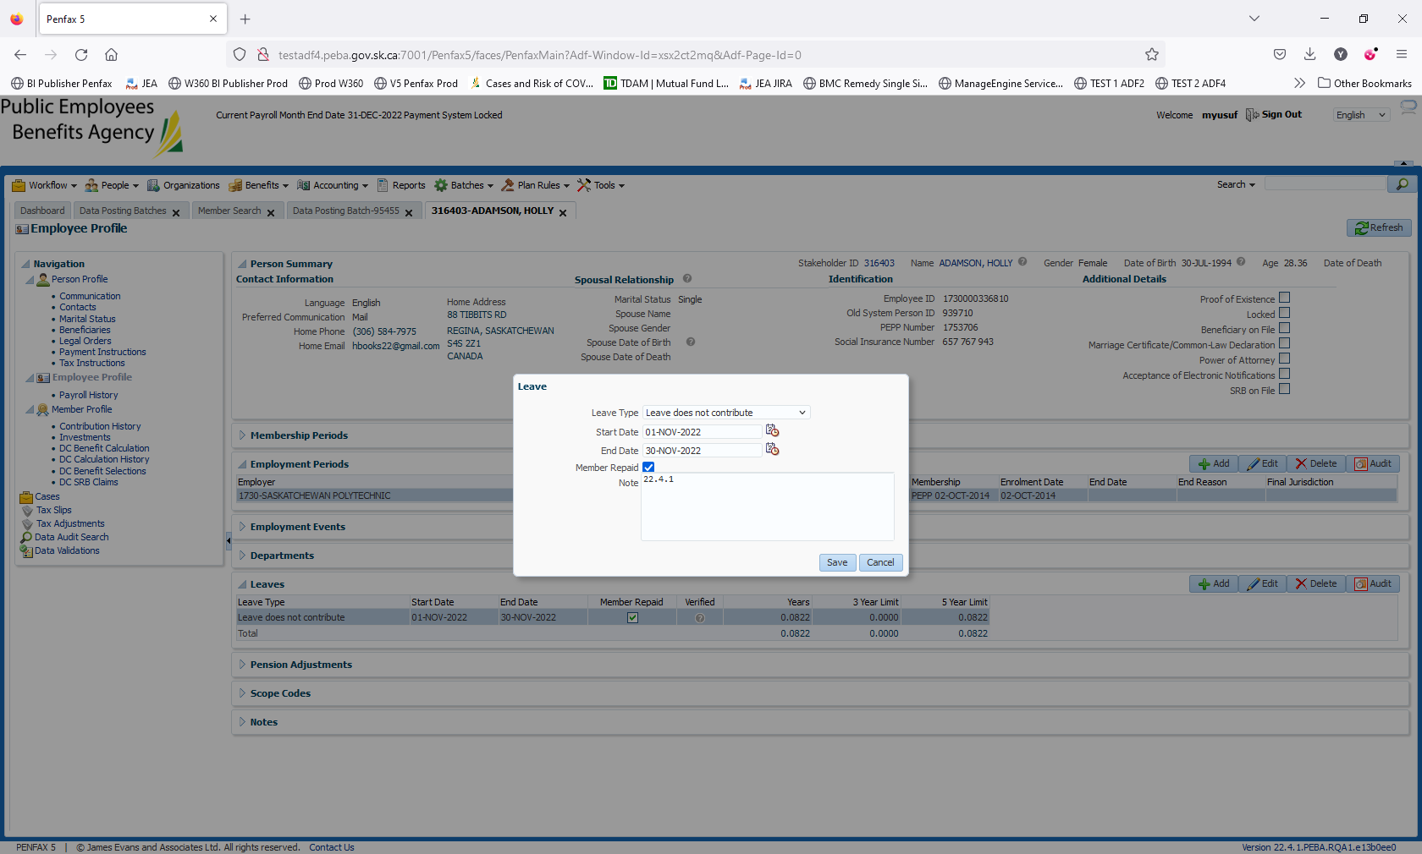

Ensure that you tick Member Repaid checkbox

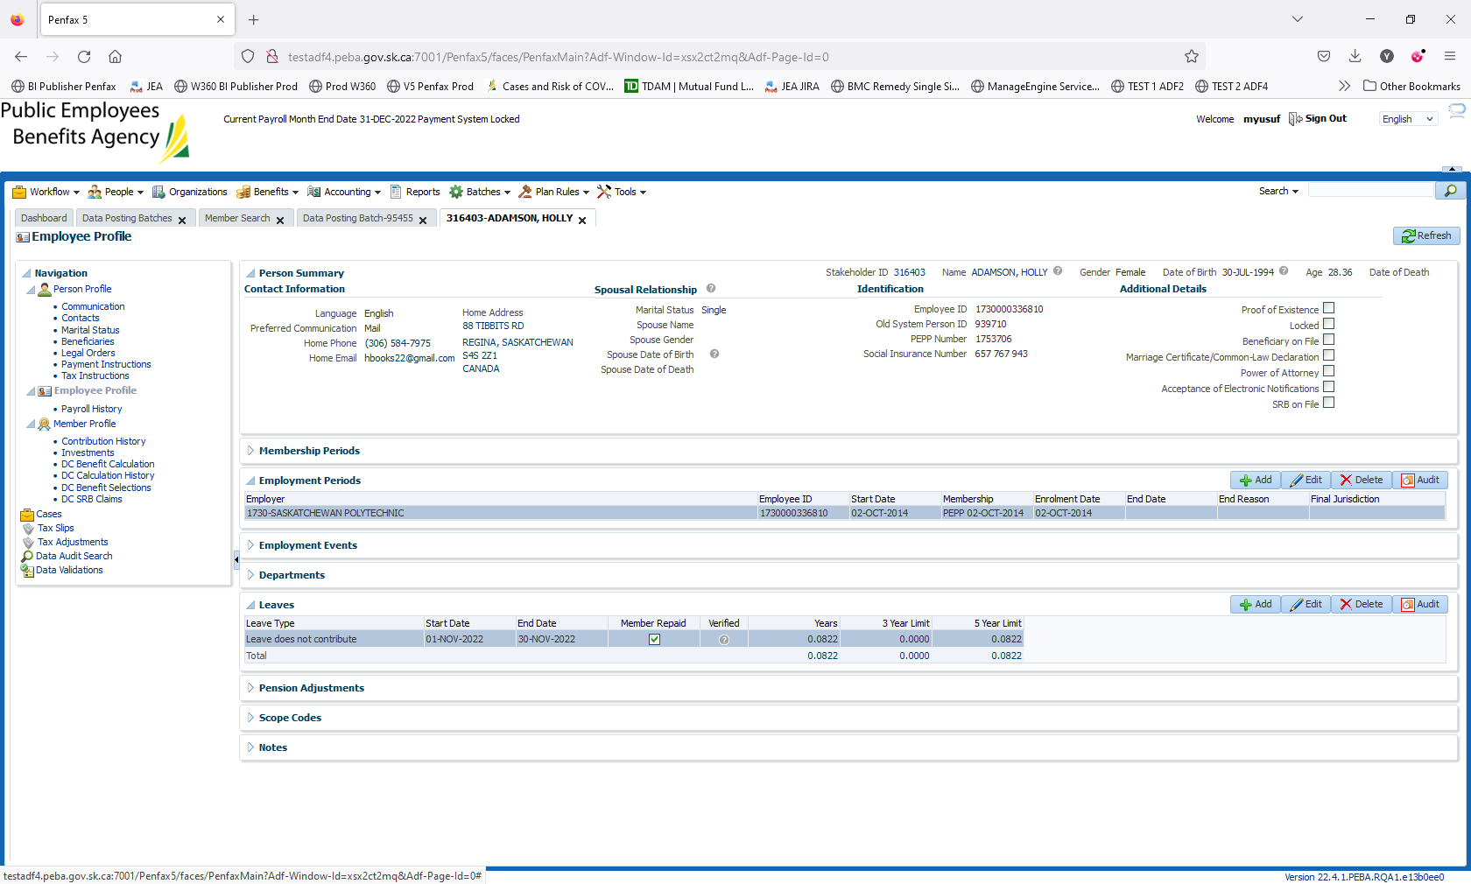

Now navigate to Member Profile -> expand the drop-down for Calculated Service section.

Validate if the Contributory Service has been affected after adding the leave.

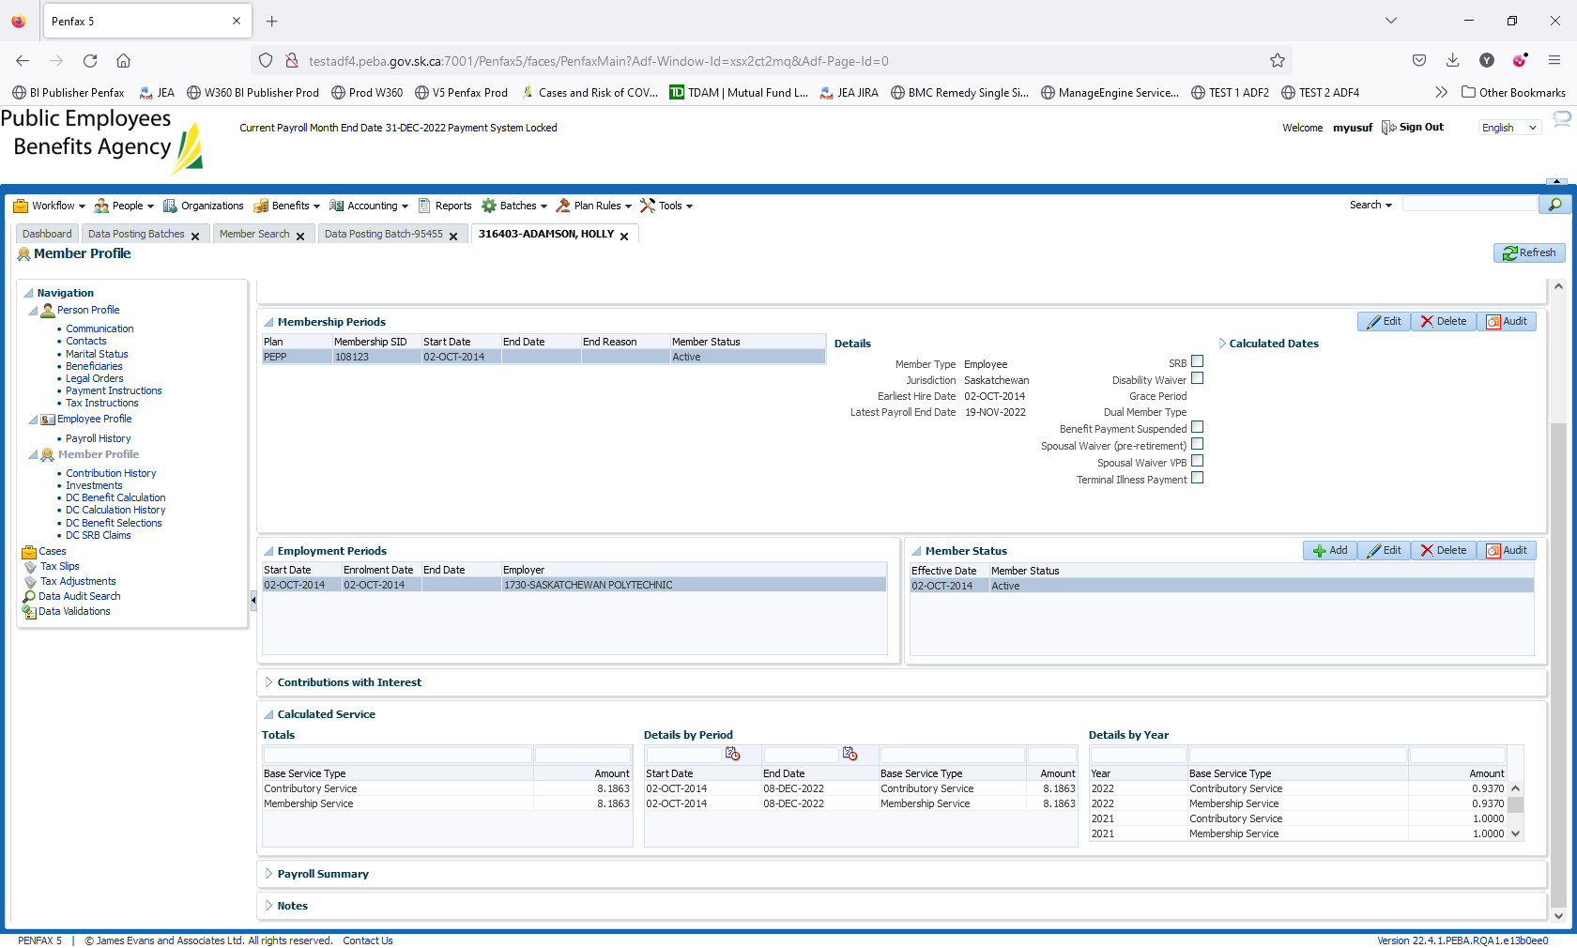

It should not affect the contributory Service. Test case passed